Republic of the Philippines

UNIVERSITY OF EASTERN PHILIPPINES

University Town, Northern Samar College of Science

**University Accounting System**

**(UEP)**

Jose Emmanuel C. Martinez

Bengie C. Orani

Raymer E. Surio

02/29/2024

**Introduction:**

Accounting systems are the backbone of any organization's financial health. From their humble beginnings in ancient civilizations to the sophisticated software used today, they have played a vital role in tracking income and expenses, managing cash flow, and ensuring financial well-being. This research delves into the world of accounting systems, specifically focusing on accounting standards. By examining the historical evolution of accounting practices, exploring current trends and challenges, and analyzing relevant academic research, this study aims to contribute to a deeper understanding of how accounting systems function and how they can be further optimized in today's dynamic business environment.

**Background of the Study:**

The concept of tracking financial transactions dates back to the earliest civilizations, with clay tablets and papyrus scrolls serving as the first recording methods. The revolutionary development of double-entry bookkeeping in the 14th century brought a new level of accuracy and balance to financial reporting. As businesses grew more intricate in the 19th and 20th centuries, accounting systems adapted to handle increasingly complex financial data. The mid-20th century saw the computer revolution fundamentally transform accounting practices. Computerized systems enabled faster, more efficient, and more accurate recording, tracking, and analysis of financial information.

In today's business landscape, accounting systems are essential for various functions, including:

* Maintaining accurate records of income and expenses.
* Monitoring cash flow for optimal financial management.
* Generating financial statements for stakeholders and regulatory bodies.

**Objectives of the study:**

1. **Evaluate the effectiveness of accounting systems in recording and reporting financial transactions:** This objective ensures that the system captures all relevant financial activity accurately and presents it in a clear and understandable way.
2. **Assess the efficiency of accounting systems in processing and analyzing financial data:** The study might explore how well the system can handle the volume of data, automate tasks, and generate meaningful financial reports.
3. **Examine the role of accounting systems in ensuring compliance with accounting standards and regulations:** This objective looks at how the system helps businesses adhere to relevant accounting principles and avoid any regulatory issues.
4. **Investigate the impact of technological advancements on accounting systems and practices:** A common area of study is how new technologies like cloud computing, artificial intelligence, and blockchain are changing the way accounting systems operate.
5. **Identify and address challenges associated with data security and internal controls within accounting systems:** This objective focuses on the system's ability to safeguard sensitive financial information and prevent errors or fraud.
6. **Explore opportunities for improving the design and functionality of accounting systems to meet the evolving needs of businesses:** The study might propose ways to make accounting systems more user-friendly, adaptable, and capable of handling the complexities of modern business environments.

**Scope and Delimitation:**

**Scope**

This study will examine the effectiveness of the current accounting system at UEP in facilitating efficient financial management practices.

* **Functionality:** Assess the system's ability to record and process financial transactions for various university departments
* **Reporting:** Evaluate the efficiency and accuracy of generating financial reports for internal and external reporting requirements.
* **User Friendliness:** Investigate the user experience for administrators and staff working within the accounting system, focusing on ease of use and functionality.

**Data collection will involve a combination of:**

* System reports and documentation analysis.
* Observation of accounting processes within the university.

**Delimitation**

This study will not delve into the potential applications of Artificial Intelligence (AI) within the university accounting system. The focus will be on the current system's functionalities, limitations, and potential for optimization without involving AI technology.

Additionally, the research will not explore alternative accounting software solutions or conduct comparisons with other universities' accounting systems. The primary focus will be on evaluating the effectiveness of the existing system in place at UEP.

Furthermore, this study will not address specific accounting principles or standards in detail, unless directly relevant to the identified areas of functionality, reporting, or internal controls.

**Significance of the Study:**

**Improved Financial Management:** By examining the effectiveness of the current accounting system at [University Name], the research can identify areas for improvement, leading to more efficient financial management practices. This can ensure better allocation of resources for educational programs, faculty research, and student support services.

**Enhanced Reporting:** Evaluating the reporting capabilities of the system can contribute to generating more accurate and timely financial reports. This benefits internal stakeholders, allowing them to make informed decisions about resource allocation and budget planning. Additionally, it ensures compliance with external reporting requirements for regulatory bodies and accreditation agencies.

**Increased User Satisfaction:** Investigating the user experience with the accounting system can lead to recommendations for improving its user-friendliness and functionality. This can enhance staff productivity within the accounting department and contribute to overall departmental efficiency.

By addressing these aspects, the study contributes to the efficient management of university finances, promotes transparency through accurate reporting, and ultimately benefiting the entire university community.

**METHODOLOGY**

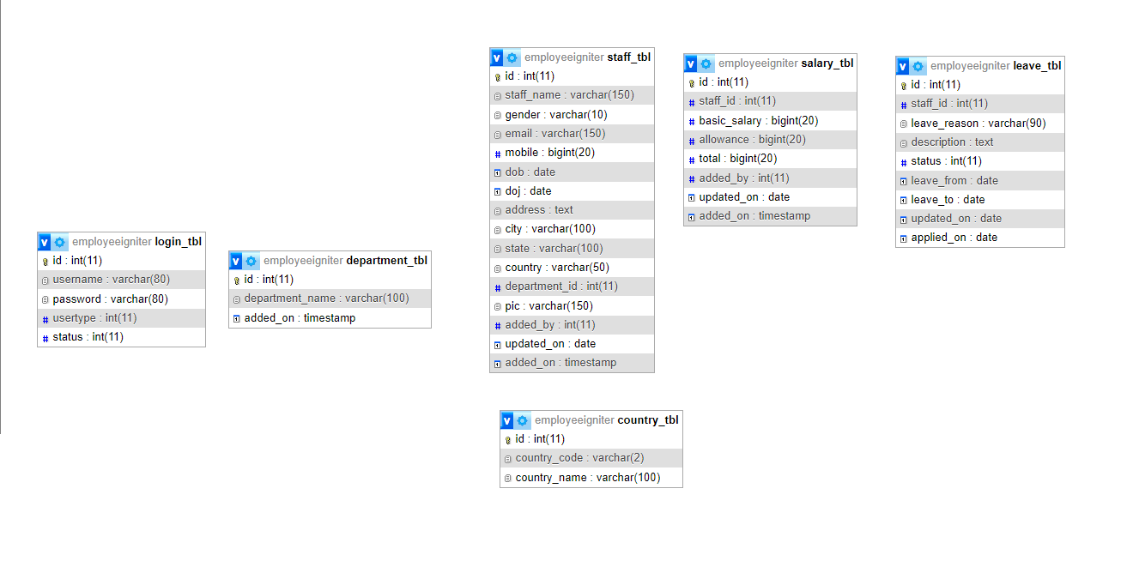

**Software specification**

Designing a software specification for a university accounting system involves outlining the functional and non-functional requirements, system architecture, user interface design, and other essential aspects. Below is an outline of what a software specification for a university accounting system might include:

**1. Introduction**

- Overview of the university accounting system.

- Purpose and objectives of the software specification document.

- Scope of the project.

**2. System Overview**

- Description of the university accounting system.

- Key functionalities and features to be implemented.

- Users and stakeholders involved (e.g., accounting staff, administrators,).

**3. Functional Requirements**

- Detailed description of system functionalities:

**Financial Management:**

- General ledger management.

- Accounts payable and receivable.

- Budget management.

- Financial reporting.

**Integration:**

- Integration with other university systems (e.g., student information system, payroll system).

**User Management:**

- User authentication and authorization.

- Role-based access control.

**4. Non-Functional Requirements**

- Performance requirements:

- Response time for transactions.

- System availability and reliability.

**- Security requirements:**

- Data encryption.

- User authentication mechanisms.

- Access control policies..

**5. System Architecture**

- High-level architecture diagram:

- Components/modules of the system.

- Database design and schema.

- Integration points with external systems.

**6. User Interface Design**

- Mockups or wireframes of key user interfaces:

- Dashboard for financial overview.

- Forms for data entry (e.g., invoice creation).

- Reports and analytics screens.

**7. Data Management**

**- Database schema design:**

- Tables and relationships (e.g., students, courses, transactions).

- Data migration and conversion requirements.

**8. Testing and Quality Assurance**

**- Testing strategy:**

- Types of testing (e.g., unit testing, integration testing, user acceptance testing).

**- Quality assurance processes:**

- Bug tracking and resolution.

- Performance tuning.

**Hardware Specification**

Designing a hardware specification for a university accounting system involves specifying the necessary hardware components and infrastructure to support the software application effectively. Below is an outline of key considerations for the hardware specification of a university accounting system:

**1. Server Infrastructure**

**-Server Requirements:**

- Identify the type of server(s) needed (e.g., physical server, virtual machine).

- Determine the processing power (CPU) and memory (RAM) requirements based on expected workload.

- Consider storage capacity (e.g., HDD, SSD) for database storage and application files.

**-Database Server:**

- Separate database server for optimal performance.

- Choose a database management system (, MySQL,) based on scalability and compatibility with the accounting software.

- Ensure sufficient memory and disk space to handle data processing and storage needs.

**2. Networking Infrastructure**

**- Local Area Network (LAN):**

- Networking equipment (e.g., switches, routers) to connect servers and client devices.

- Network bandwidth requirements based on expected concurrent user connections and data transfer.

- XAMPP.

**3. Client Devices**

**-Desktop Computers:**

- Specification for client machines (e.g., CPU, RAM, storage) for accounting staff.

- Consider compatibility with the accounting software and other required applications.

**-Laptops:**

- Specifications for mobile workstations if accounting staff require mobility.

- Battery life and connectivity options (e.g., Wi-Fi, Ethernet).

**4. Backup and Disaster Recovery**

**-Backup Server or Storage:**

- Implementation of backup solutions (e.g., RAID, cloud backup) for data protection and disaster recovery.

- Specify backup schedule and retention policy.